Christy it looked like you got off to a great start. I really liked how you…I thought, though, that the end was a bit weak. Perhaps you would like to add something about…
Christy Keeler
January 18, 2005
Editor: Johnny Appleseed
Edited: 1/26/05
Final Draft: Date

Technology Journey I: Draft

My technology journey started when I was yadda, yadda, madda.. Yadda, yadda, yadda... Yadda, yadda, yadda... Yadda, yadda, yadda... Yadda, yadda, yadda... Yadda, yadda, yadda... Yadda, yadda, yadda... Yadda, yadda, yadda... Yadda, yadda, yadda... Yadda, yadda, yadda... Yadda, yadda, yadda... Yadda, yadda, yadda... Yadda, yadda, yadda... Yadda, yadda, yadda... Yadda, yadda, yadda... Yadda, yadda, yadda... Yadda, yadda, yadda... Yadda, yadda, yadda... Yadda, yadda, yadda... Yadda, yadda, yadda... Yadda, yadda, yadda... Yadda, yadda, yadda... Yadda, yadda, yadda... Yadda, yadda, yadda... Yadda, yadda, yadda... Yadda, yadda, yadda... Yadda, yadda, yadda... Yadda, yadda, yadda... Yadda, yadda, yadda... Yadda, yadda, yadda... , yadda, yadda...
My first experience with a digital camera was when I yadda, yadda, yadda... Yadda, yadda, yadda... Yadda, yadda, yadda... Yadda, yadda, yadda... Yadda, yadda, yadda...
Christy, can you center this pictutre?
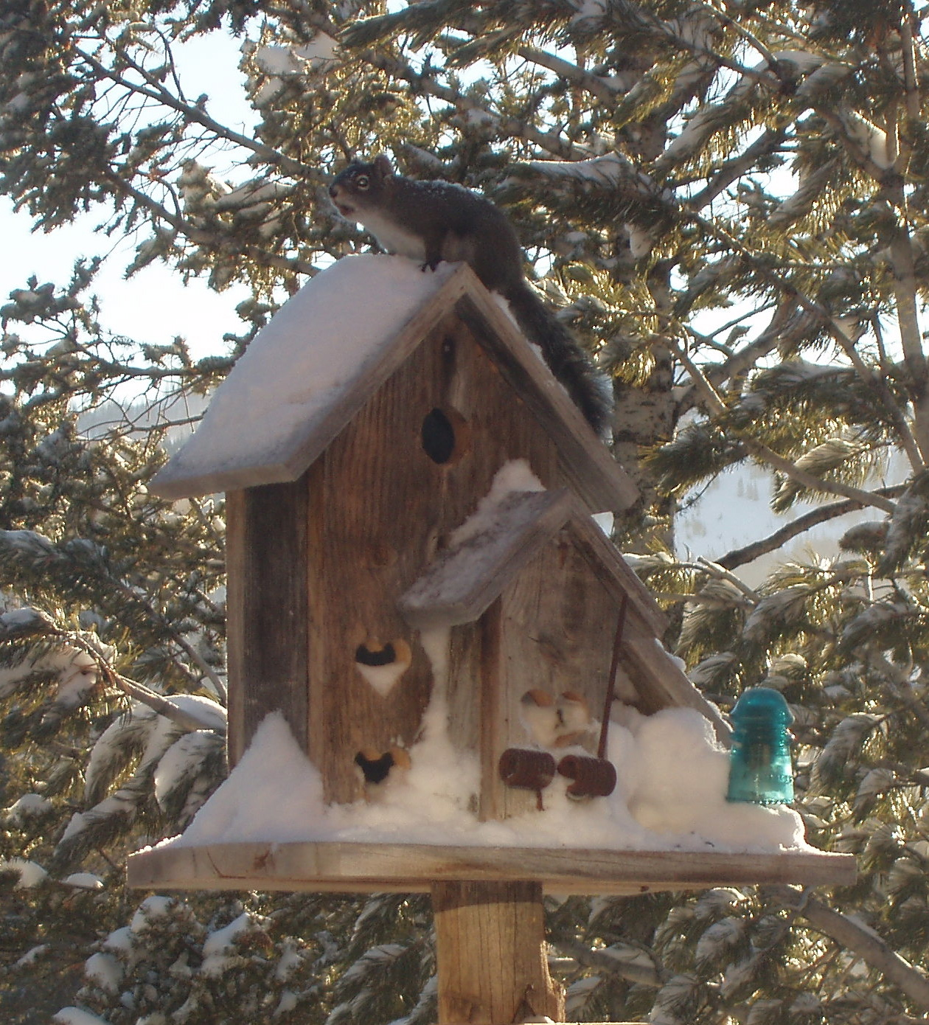
Here is how good I am now!
My first experience with KidPix was not quite as successful. When asked to describe my feeling about technology by creatively using KidPix, I was first scared and then frustrated. After spending some time talking with my classmates and learning from them, here was the result of my labor:

There are several ways I would like to use technology in my future classroom. I would like to incorporate the following technologies in the below-specified order:
- Use digital cameras to teach students about their physical environment.
- Use concept-mapping software to help students organize their thoughts before taking field trips.
- Etc.Things I would like to learn in this class include:
- X
- Y
There is a lot that I like about technology, but also a lot I dislike. Some of these items appear in the table below:
Things I Like/Dislike about Technology
Like | Dislike
I can compute math facts quickly | It takes a long time to learn new technologies
It’s cheaper to use digital cameras than to develop film | I never know who to contact when a technology is not working

