 |  | Teaching? My portfolio
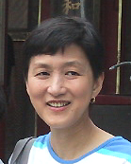 | Text box
Eugenia Y. Yao
About Me
My Lesson Plans
Favorite Readings
Favorite Websites
Educational Software
Artifacts
 |  | © 2005 Eugenia Yao

